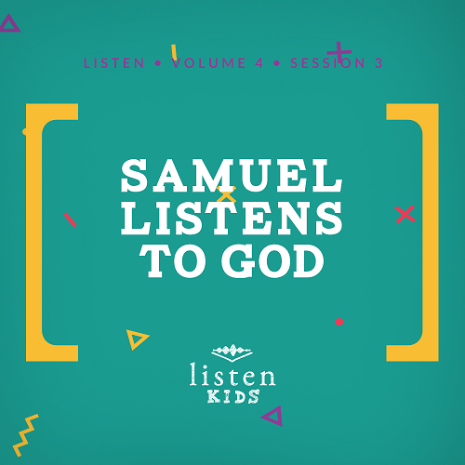Leader Overview
Our God wants relationship with His people. He wants His sons and daughters to know Him, and the key ingredient to knowing someone is communication. Throughout time, God has spoken to people. Some have chosen to follow Him and others to turn away, but He still speaks. He calls out to those He loves. The really good news for us today is He still speaks to us!

Bible Lesson
Eli and Samuel
1 Samuel 3:1–10
Faith Fact
God speaks to me.
Faith Verse
Isaiah 41:10 (NLT)
“Don’t be afraid, for I am with you. Don’t be discouraged, for I am your God. I will strengthen you and help you. I will hold you up with my victorious right hand.”

Preparing for the Session
Leader Preparation Time: 20–25 Minutes
You Will Need
Large Group
- Bible
- Worship songs (Song suggestions: “Real Love” by Hillsong Young & Free; “Chain Reaction” by River Valley Worship; “Good Good Father” by Chris Tomlin)
- For groups not using a phone or tablet only, add:
• Projector or TV
• Laptop
• Rules Video or Slide
• Faith Fact Slide
• Faith Verse Video or Slide
• Bible Lesson Slides 1–3
• Bible Lesson Video A
• Bible Lesson Video B
Small Group
- Small Group Activity Page, one per kid
- Small Group Group Connection page, one per group
- Small Group Faith Verse Review page, one per kid
- Pens, one per group
- Sandwich bags, one per kid
- Scissors
- Crayons or markers

To download session videos, slides, and printables, visit: BibleEngagementProject.com/downloads

Getting Ready
Large Group
Download videos and slides if needed.
- Select worship song(s) and have them ready to play.
Small Group
- Print the Small Group Activity Page, one per kid.
- Print the Small Group Group Connection page, one per group.
- Print the Small Group Faith Verse Review, one per kid.
- Cut out the puzzle pieces of the Faith Verse Review page for each kid.
- Place the puzzle pieces in sandwich bags, one per kid.

First time leading Listen for Kids? Check out the Facilitator Guide.

Large Group
30 Minutes
See what’s needed at the beginning of the session.

Introduction
Welcome! It’s so great to see you again! (Continue talking so quietly that the kids can’t hear you. After you’ve made your point continue.) Communication is so important. If you can’t hear what I’m saying, then you won’t be able to hear what we’ll be doing today. What we’re going to talk about is really important!
Did you know that God speaks to me? He does. Did you know He speaks to you? He loves His sons and daughters and really loves talking with them. That means you. God wants you to hear His voice and obey what He’s telling you to do. He also wants you to talk back! That’s prayer—listening and talking to God.
Today in the Bible, we’re going to meet a boy named Samuel. God had special things for Samuel to do in his life. As Samuel grew, he did many great things for God. But first, he had to learn to listen to God’s voice. God was speaking to Samuel. Was he going to listen?
Before we get started, let’s take a look at our Faith Fact.
• Show the Faith Fact Slide.
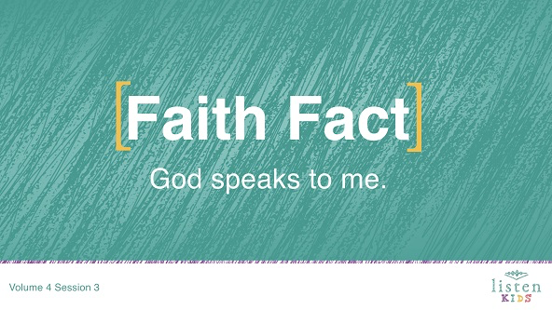
Let’s say it all together: God speaks to me. Let’s do it one more time! God speaks to me. Great job!
Rules Review (Optional)
Great job! Do you want to have fun today? (Group response) Me, too. Before we get started, we need to make sure that we all know the rules.
• Play Rules Video.
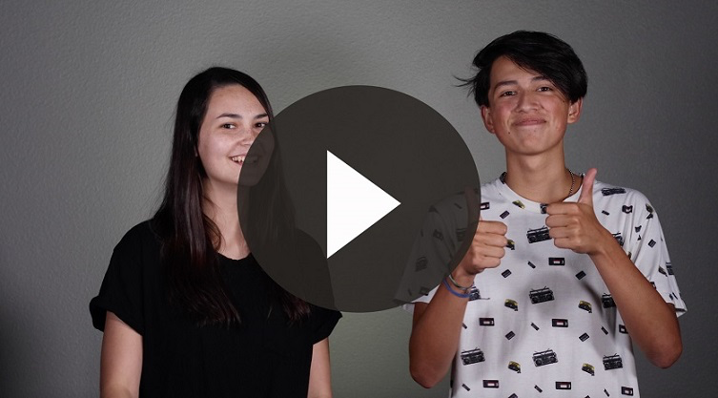

Game
Telephone Game
Now that we’ve talked about what we’re going to explore today, who wants to play a game?
How many of you have played the Telephone Game before? Let’s sit in a large circle. I am going to whisper something into the ear of the person next to me. Then, that person is going to repeat what they heard to the next person. This will continue until it gets back to me. Now, listen carefully because we can only say it one time. No repeating and no helping. Are you ready?
• Whisper a short statement to the first kid. (Example: I like hot fudge sundaes with sausage and pickles on it.)
• End the round by having the last person in the circle repeat what he or she heard. Tell the group what you actually said.
This time, we are going to split the group in half and do it again.
• Form two groups and play another round.
Finally, we are going to break off into pairs. Each of you will take turns whispering to each other.
• Form pairs of kids and play another round.
Did you notice that it was easier to hear and understand when you were in the smaller group? (Group response) Was it even easier when you were in pairs? (Group response) It’s the same thing with talking with God. The closer we are to Him, the easier it is to hear Him. We understand better without other distractions.

Worship
That was so much fun. Now, it’s time to praise God! Are you ready? Get on your feet. Here we go!
• Lead the kids in singing one or two praise songs. See suggestions at the beginning of the session.

Bible Lesson
Have you ever wondered how you’re going to hear God if He speaks to you? I know I have, but I know the best place to find the answer. Do you know what it is? (Group response) It’s in God’s Word, the Bible. (Hold up your Bible.) Let’s take a moment to pray and invite God to be with us.
Prayer
Dear God, thank You for speaking to us. Help us to recognize Your voice. Then help us to do what You tell us to do. Amen.
Video Intro
Before we start hearing from God’s Word, let’s check in with Dash and Austin and see what they’re up to!
• Play Bible Lesson Video A.
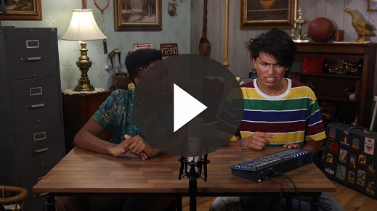
Wow! Would you like to accept that challenge? (Group response) That’s the perfect lead-in to our Bible story today!
Bible Story
(Open the Bible to Samuel.) So far, we have heard that when Israel entered the Promised Land, God appointed spiritual leaders called judges. These judges ruled during the times when Israel needed extra help. In between judges, the Israelites would get careless about following God and end up disobeying Him. They would get in trouble and then cry out to God. He would always deliver them by sending a judge. The judges would always point the people back to God!
Today’s story begins with a man named Elkanah, who lived during the time of the judges. Elkanah was from the city of Ramah, and each year he traveled to Shiloh to worship God and bring Him sacrifices. This yearly trip to Shiloh made his wife Hannah very sad because she didn’t have any children and she wanted them.
One time after eating the special meal called a feast, Hannah went to pray. As she prayed, she began to cry bitterly to God. Let’s read what she prayed in 1 Samuel 1:11.
• Read 1 Samuel 1:11.
Can you believe that? She told God that if He gave her a son, she would give him back to God forever. Do you think God heard her prayers? (Group response)
As Hannah was praying, the priest named Eli saw her. He thought the way she was acting was very strange. Hannah said that she was sad and had been pouring her heart out to the Lord. Eli said, “May the God of Israel grant the request you have asked of Him.” After that, Hannah went back to eat and wasn’t sad anymore.
• Show the Bible Lesson Slide 1.
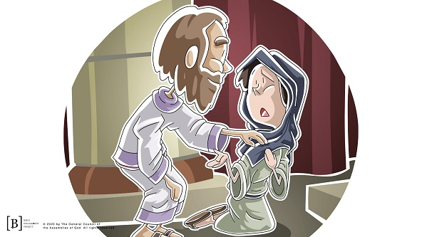
Elkanah and his family returned home to Ramah, and do you know what happened? Hannah found out she was pregnant! She gave birth to a son and named him Samuel. Hannah had prayed and cried out to God. God heard her and had answered her prayer.
When Samuel was several years old, the family went back to Shiloh and Hannah brought him to Eli, the priest. She told Eli that Samuel was a gift from God and that she was keeping her promise to give him back to the Lord. Then, the family worshipped together, and Hannah praised God for what He had done. Samuel was to grow up with Eli, serving him, in the tabernacle.
As Samuel grew, his mom went each year to give sacrifices with Elkanah. Each time she went to the tabernacle, she brought Samuel a new coat that she had made. Eli would bless her and ask God to send her more children to take Samuel’s place. God did! Hannah had three more sons and two daughters.
Now, Eli’s sons also served as priests. Eli knew about their sin of stealing from the people’s sacrifices, which was breaking the laws of God. Samuel didn’t do the things that Eli’s sons did. Let’s see what happened next as we read 1 Samuel 3:1.
• Read 1 Samuel 3:1.
Messages from God were rare. That means they didn’t happen very often. This might have been because of the way Eli’s sons were dishonoring God. Either way, this makes what happens next to Samuel even more special.
• Show the Bible Lesson Slide 2.
One night, after Eli and Samuel had gone to bed and were sleeping in the tabernacle, Samuel heard a Voice call out to him, “Samuel.” He thought Eli must be talking to him, so he got up and ran to him. “Here I am,” he said to Eli. “Did you call me?” Eli said that he hadn’t called Samuel and told him to go back to bed.
• Show the Bible Lesson Slide 3.
Have you ever thought you heard something, but everyone else said it wasn’t there? (Group response) Hmm. Samuel went back to bed. You can imagine him getting cozy again. All of a sudden, he heard that Voice again say, “Samuel.” And again, Samuel went to ask Eli what he wanted. Eli told him that he hadn’t called him and to go back to bed.
So, Samuel went back and laid down again. Now, Samuel didn’t know it was God because he had never heard God speak to him. As Samuel was laying there, he heard the Voice again say, “Samuel.” How many times has this happened? (Group response) That’s right! For the third time, he went to Eli and said, “Here I am. Did you call me?”
Finally, Eli knew what was happening. God was speaking to Samuel! So, Eli gave Samuel these instructions: “Go and lie down, and if someone calls again, say, ‘Speak, Lord, your servant is listening’.”
So, for the fourth time, Samuel went back to his bed. As Samuel was laying there, the Lord spoke again, “Samuel! Samuel!” Samuel said, “Speak, your servant is listening.” Then, God told Samuel some news. This was going to be hard news to hear, but God had chosen Samuel to give it. Let’s read what God said in 1 Samuel 3:11–14.
• Read 1 Samuel 3:11–14.
Samuel really didn’t want to tell Eli what God had said. But, as soon as he got up and opened the doors to the tabernacle, Eli called out to Samuel and asked him what God had said. Samuel was honest with Eli and told him everything. How do you think Eli responded? (Group response)
Eli accepted what God said and told Samuel that God must do what He thinks is best. Samuel had heard from the Lord, and he had delivered the message just as he was told. As Samuel grew, all the people of Israel trusted what he said. He was always reliable. The Lord continued to give Samuel messages in the tabernacle. Samuel was the last judge in Israel.
Teaching Time
Just like Samuel, God wants to speak to you. He loves it when you spend time talking to Him and listening to what He says. We can talk to Him about anything—how our day went, school, family stuff, our pets, sports, and anything else we can think of. He wants to be the biggest part of everything we do. We need to remember to talk to God all throughout our day and be listening to His voice. He is speaking, and He is always with you.
When God speaks to you and me, we might not hear the sound of His voice like Samuel did. God can speak to us in many different ways. Some people hear God’s voice with their ears, and others sense God speaking to their hearts or putting pictures in their minds. Many people find that God speaks to them by showing them important messages in the Bible. No matter how God speaks to us, we must always take time to stop, listen, and be sensitive to the words God is wanting us to hear.
Just like Samuel, God wants to speak to you. At times He will also want you to pass on words to other people. It’s important that we carefully listen for God’s voice and we always respond to God with obedience.
Faith Verse
Let’s say our Faith Verse with the actions together.
• Play Faith Verse Video.
Isaiah 41:10 (NLT)
“Don’t be afraid, for I am with you. Don’t be discouraged, for I am your God. I will strengthen you and help you. I will hold you up with my victorious right hand.”
In our Bible story, Samuel heard from the Lord when he was resting in bed. Tonight, when you’re in bed, listen to what God is saying to you. You may even want to say, “Speak, Lord, your servant is listening.” Then, listen for His voice. The more you do this, the more confidently you can say God speaks to me.

Prayer and Response
Consider playing a worship song softly in the background while kids pray.
Let’s take some time to pray and talk with God. Just as God spoke to Samuel, God wants to talk with you, too. Often we are so distracted that we can’t or don’t hear Him. Let’s close our eyes, quiet ourselves, and ask God to speak to us. Then listen.
• Give kids time to pray. Then introduce the worship song. This could play in the background while kids pray or could be a worship song to sing together.
• If you have time, consider having the kids write down the messages that God is speaking to them.
Worship Song
Play a worship song. See suggestions at the beginning of the session.
Video Wrap-Up
Just before we go to our small group activities, let’s see how Dash and Austin’s challenge worked out.
• Play Bible Lesson Video B.
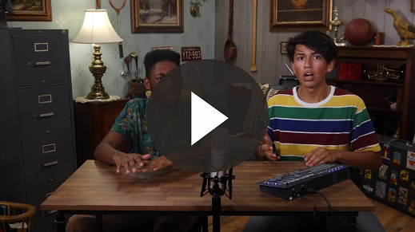
Let’s all accept the challenge to find a quiet spot and listen for God’s voice for at least ten minutes.
• Show the Faith Fact Slide.
Before we move to Small Group time, let’s practice our Faith Fact one more time. Say it with me. God speaks to me. Thanks for a great time learning about God together.
• Dismiss kids to Small Group time or to go home if your group time ends here.

Small Group
30 Minutes
This section can be done in conjunction with the large group, or on its own if you do small groups with your kids. During Small Group time, the goal is to connect the kids with the Word of God and to each other. All activities are led by the small group leader.

Group Connection
Mad Lib
You Will Need
- Small Group Group Connection page, one per group
- Pens, one per group
Getting Ready
- Print the Small Group Group Connection page, one per group.

We are going to have a little fun with a Mad Lib. Mad Libs can work like this. First, I’m going to read a simple story about Samuel the way it happened. Then, we will complete this Mad Lib and make a silly version.
• Have one kid ask for the Mad Lib answers and fill them in on the paper.
• Have another kid read the completed mad lib to the group.

Bible Lesson Recap
You Will Need
- Bible, one per kid

No prep needed for this activity.

Bible Story Review: 1 Samuel 3:1–10
Let’s read how Samuel discovered God was speaking to him.
• Divide the Bible reading into smaller chunks for volunteers to read aloud if needed.

Faith Fact
God spoke to Samuel, and God speaks to us, too. He uses men, women, boys, and girls to do what He wants done!
• Show the Faith Fact Slide.
Point to yourself and say the Faith Fact with me: God speaks to me. You’re not too young for God to speak to you!

Group Discussion
Feel free to use all or just a few questions as a jumping-off place for good discussion. Questions marked with * are designed for more conversation. Adjust the questions based on the age or maturity of your group. Typically, older children will be able to dive a little deeper than younger ones.
Questions
Who was Samuel’s mother?
How do you think Samuel felt when God first called him before he realized it was God?
How do you think Samuel felt when Eli kept saying that he didn’t call for Samuel?
Do you like being awakened in the middle of the night? Are you pleasant or grumpy? Are you cooperative or hard to deal with?
God gave Samuel a serious message to give to Eli. How would you feel if you were Samuel?
Samuel was obedient when he shared God’s message with Eli. What else did he show?
* What kind of message does God want you to share with others?
* Have you ever heard God speak to you? What message did He give you?
* What are some ways we can hear God’s voice?

Application and Response
God called out to Samuel in the middle of the night because He had a message He wanted Samuel to share. God has a message for you, too, but we have to take the time to listen to Him. Hey, that reminds me of our Faith Fact: God speaks to me.
• Show the Faith Fact Slide.
Who can say it louder—boys or girls? (Group response) Let’s have the girls say it first: God speaks to me. Okay, boys. Your turn! Can you say it louder than the girls? Say it now: God speaks to me. I think it was a tie!
Make It a Habit
Select a simple visual reminder of the session’s Faith Fact.
Let’s make a habit to remember what we’ve learned about God today. We can be creative just like our God is. Let’s come up with a way to remember that God speaks to us.
For example, I could think about how God speaks to me every time I look at a telephone this week. What do you think we should use to remember?
• Make notes of what the kids share.
Prayer
Let’s pray and ask God to help us.
Thank You, God, for speaking to us. We read about how You spoke to people in the Bible, but we know You’re still speaking to Your people today. Help us to hear and listen to Your voice. Amen.

Faith Verse Review
You Will Need
- Small Group Faith Verse Review page, one per kid
- Sandwich bags, one per kid
- Scissors
Getting Ready
- Copy the Small Group Faith Verse Review page, one per kid.
- Cut out the puzzle pieces of the Faith Verse.
- Place the pieces for each puzzle in a sandwich bag for each kid to take home.

Note: If your small group is large, consider breaking into smaller groups and having kids do this as a team. Then give each kid a puzzle to take home.

Our Faith Verse for today is Isaiah 41:10. That verse is God speaking and telling us that we don’t need to be afraid, that God is with us, and that He will help us. When we know God’s Word, He can bring a verse or Bible story to mind just when we need it. Let’s say it and do the actions.
• Show the Faith Verse Slide.
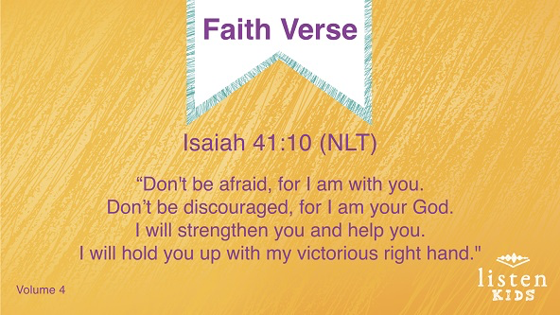
Isaiah 41:10 (NLT)
“Don’t be afraid, for I am with you. Don’t be discouraged, for I am your God. I will strengthen you and help you. I will hold you up with my victorious right hand.”
Let’s lock this verse in our hearts and minds so that we always remember it!
• Repeat the verse several times. Get creative with the verse practice. Split the group up and have them compete. Try saying it in different voices or pitches. Ask individual kids to choose how to practice it. Have fun!
Faith Verse Fun
Okay kids, are you ready for some more fun? Let’s have a little race. Here’s a sandwich bag that has our Faith Verse cut into pieces. When I say go, you are going to put the pieces of the verse together in the correct order. I’m not going to show you what the final verse should look like. You have to figure that out. Who thinks they are ready? (Group response) Ready, set, go!
• Help younger kids if needed.
Note: If your small group is large, consider breaking into smaller groups and having kids do this as a team. Then give each kid a puzzle to take home.

Creative Activity
Samuel Hears God
You Will Need
- Small Group Activity Page, one per kid
- Crayons or markers
Getting Ready
- Print copies of the Small Group Activity Page, one per kid.

God spoke to Samuel in the night while Samuel was sleeping. How many of you pray before you go to sleep? (Group response) I like to do that. It’s a perfect time to talk with God because you don’t have distractions like people talking, the TV, or homework. When we lie quietly in our beds, we can talk to God about whatever we want. We can even listen to God. Let’s use this picture as a reminder to pray.

Faith Fact Recap
• Display the Faith Fact Slide as parents are coming into the room.
• Maximize the time you have with your kids so that parents see what their kids have learned. Have the kids repeat the Faith Fact and then dismiss them to their parents.
Something important to remember from today is our Faith Fact.
• Show the Faith Fact Slide.

Say it with me: God speaks to me. Now, that’s what I’m talking about! See you soon!

Dismissal
• Send home the Small Group Activity Page and the Faith Verse puzzle with each kid.
• Remind parents that there are Family Devotions available on the app to do with their kid.
• Tell everyone the date and time for the next session.

